di dgv cari di Properties ; Coloumn - ( Collection ) Click
Ini untuk membuat Coloumn - coloumn Grid nya

Tentukan nama (name grid coloumn) dan Text nya ( text header nya )

Beri nama Coloumn Gridnya
Misal :

KODE BARANG = mkdbrg
NAMA BARANG = mnabar
SATUAN = msatuan
JUMLAH = mjumlah
HARGA = mharga
SUBTOTAL = mtot

Dan perhatikan Coloumn Type nya : lihat gambar

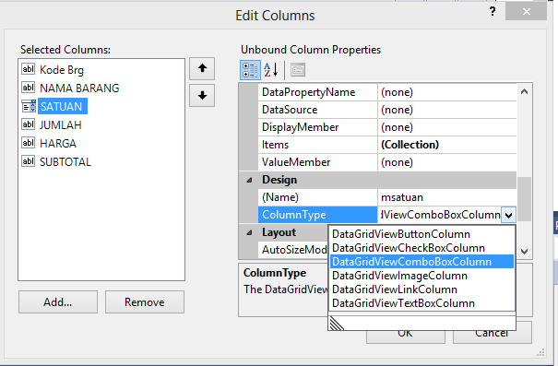

ferent nya :
ini codingnya :
Imports MySql.Data.MySqlClient
Imports System.Data

Module Module1
Public vkdbrg, vnabar, vsat As String
Public vjumlah As Integer
Public vharga As Integer
Public vtot As Integer
Public cmd As New MySqlCommand
Dim serv As String = "Server=localhost;"
Dim dbase As String = "Database=toko;"
Dim uid As String = "uid=root;"
Dim pwd As String = "pwd=;"
Dim ConString = serv & dbase & uid & pwd
Public db As New MySqlConnection(ConString)
Public Sub konek()
Try
tutupDB()
db.Open()
MsgBox("Koneksi DataBase berhasil dilakukan")
Catch ex As MySqlException
MsgBox(ex.Message)
MsgBox("Koneksi tidak berhasil dilakukan")
End Try
End Sub
Public Sub tutupDB()
If db.State = ConnectionState.Open Then
db.Close()
End If
End Sub

End Module
*****************

Setelah itu Coding Simpan nya :

Imports MySql.Data.MySqlClient
Imports System.Data
Public Class Form1

Private Sub dgv_CellEndEdit(ByVal sender As Object, ByVal e As System.Windows.Forms.DataGridViewCellEventArgs) Handles dgv.CellEndEdit
If e.ColumnIndex = 3 Then
dgv.Rows(e.RowIndex).Cells(5).Value = dgv.Rows(e.RowIndex).Cells(3).Value * dgv.Rows(e.RowIndex).Cells(4).Value
ElseIf e.ColumnIndex = 4 Then
dgv.Rows(e.RowIndex).Cells(5).Value = dgv.Rows(e.RowIndex).Cells(3).Value * dgv.Rows(e.RowIndex).Cells(4).Value
End If
End Sub

Private Sub Button2_Click(ByVal sender As System.Object, ByVal e As System.EventArgs) Handles Button2.Click
konek()
Dim cmd As New MySqlCommand("INSERT INTO temporary_beli(kdbrg,nabar,satuan,jumlah,harga,subtotal) VALUES (@mkdbrg,@mnabar,@msatuan,@mjumlah,@mharga,@mtot)", db)
Try

For i As Integer = 0 To (dgv.Rows.Count - 2)

vkdbrg = dgv.Rows(i).Cells(0).Value
vnabar = dgv.Rows(i).Cells(1).Value
vsat = dgv.Rows(i).Cells(2).Value
vjumlah = dgv.Rows(i).Cells(3).Value
vharga = dgv.Rows(i).Cells(4).Value
vtot = dgv.Rows(i).Cells(5).Value

cmd.Parameters.AddWithValue("@mkdbrg", vkdbrg)
cmd.Parameters.AddWithValue("@mnabar", vnabar)
cmd.Parameters.AddWithValue("@msatuan", vsat)
cmd.Parameters.AddWithValue("@mjumlah", vjumlah)
cmd.Parameters.AddWithValue("@mharga", vharga)
cmd.Parameters.AddWithValue("@mtot", vtot)
cmd.ExecuteNonQuery()
cmd.Parameters.Clear()
Next
Catch ex As Exception
Beep()
MsgBox(ex.Message, MsgBoxStyle.Information, "Informasi")
cmd.Dispose()
End Try
End Sub

End Class
*************

Setelah itu Save all

Kita Cek sebelum di jalankan DataBase nya Kosong isinya :

